Introduction to Quality Improvement

Guidebook

Table of content
What is Quality Improvement? 3
The IHI Model for Improvement 4
What are we trying to accomplish? 6
5 P’s assessment 6
Encouraging partners to form the right team 6
Identifying your stakeholders 8
Partnering with patients, carers and the public 9
FAQ’s 10
Build a shared purpose 12
The value in aim setting 13
Driver diagrams 14
Process mapping 16
How will we know a change is an improvement? 18
How do you measure for improvement? 18
Baseline data 19
Displaying data 20
Variation 20
Key rules of measurement for improvement 21
What changes can we make that will result in improvement? 22
Brainstorming 22
Creative thinking 23
Behavioural Insights 23
Six Thinking Hats 26
Change ideas 28
The innovation adoption curve 28
Plan, Do, Study, Act (PDSA) cycles 30
PDSA basics 30
For each test of change, run the PDSA cycle as follows 31
Features of PDSAs 31
PDSA Example 34
Q & A 35
Life platform 37
Further support 37
Acknowledgements 37
Appendix A: Stakeholder Analysis 38
Glossary 40

What is Quality Improvement?
- Quality improvement (QI) is about improving patient (and population) outcomes, system performance and professional development.
- The Institute of Healthcare Improvement (IHI) has developed the Model for Improvement (MFI) which is one type of QI methodology. The MFI is being successfully adopted in many healthcare settings to improve patient care.
- More than a methodology, QI is about a change in behaviours, working together, change coming from the bottom up, creative thinking and fundamentally, using measurement to guide improvement.

The STEEP slope to quality

There are six domains of health care quality which are the following:

- Safe: Avoiding harm to patients from the care that is intended to help them.
- Timely: Reducing waits and sometimes harmful delays for both those who receive and those who give care.
- Effective: Providing services based on scientific knowledge to all who could benefit and refraining from providing services to those not likely to benefit (avoiding underuse and misuse, respectively).
- Efficient: Avoiding waste, including waste of equipment, supplies, ideas, and energy.
- Equitable: Providing care that does not vary in quality because of personal characteristics such as gender, ethnicity, geographic location, and socioeconomic status.
- Patient-centered: Providing care that is respectful of and responsive to individual patient preferences, needs, and values and ensuring that patient values guide all clinical decisions.

The IHI Model for Improvement
The model for improvement has two parts:

- Three fundamental questions
- The Plan, Do, Study, Act (PDSA) cycle to test changes and determine if the change is an improvement

The three questions are:
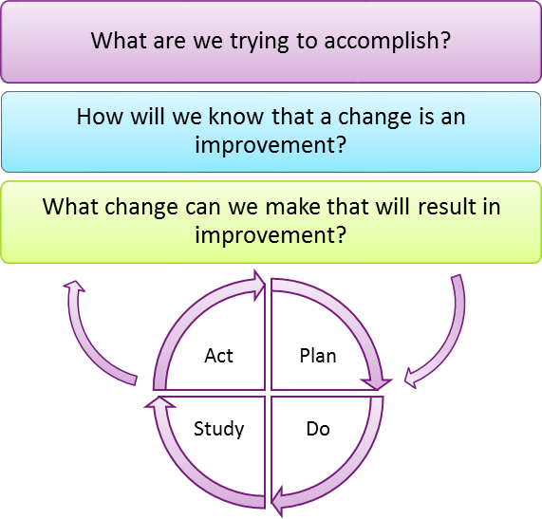

These questions should act as a guide when planning your QI project and you should refer to them during your project to ensure you are on track.

How to interpret each question?

- Set your aim and then plan your project with a process map and driver diagram.
- Regular real time measurement will inform you if changes you test bring about improvement.
- Develop ideas and test them using PDSA cycles.

Part 1
Three fundamental questions

What are we trying to accomplish?

5 P’s assessment

Purpose:

What is the function of the current team/service/clinic?

Processes:

Do you understand how things are working right now?

How should the processes work?

Patients:

Who are your patient population?

How many people are affected?

Do you understand what matters to these patients?

Professionals:

What members of health care providers to you need to engage?

Who does this affect?

What are their capabilities needs?

What matters to them?

Patterns:

What data is available?

Are there hot spots of activity?

Encouraging partners to form the right team

To ensure success and sustainability of your QI work, it is vital you get the right team together. The team should include everyone who has a stakeholder interest in your project.

The team should:

Be multi-disciplinary (MDT)

Include someone with enough seniority to make key decisions

Have permanent members of staff to ensure sustainability

Include people with specialist knowledge

Include frontline staff who will champion your work

Example

Members of a team for a QI project regarding reduction of medication errors on AMU:

Consultant supervisor ideally AMU consultant

AMU pharmacist

Ward manager/ nurse AMU

CEU officer

Perhaps a patient safety manager

Team of frontline staff to help think of ideas, measure, and champion your work

Manager/ Administrator

Identifying your stakeholders

Identifying all your different stakeholders can require a good deal of research.

Bring together a group of individuals who work within the system and understand all the key linkages within the system.

Build a list of all the people and groups likely to be affected by the proposed change.

The list should be recorded and use as a term of reference throughout the life of the project.

Prioritising your stakeholders

Once you have the list of stakeholders, you should categorise the list.

Plot each name or group on a power/impact matrix.

Consider how they are affected by the project or change to determine the level assigned to that person for project success. In doing this you will be able to identify which stakeholders will require the greatest involvement to those with only require to be informed about the change.

The more important the stakeholder is to the success of the project, the more time and resources you need to devote to maintaining their involvement and commitment.

Patients often fall into the 'inform' category.

It may be helpful to take steps to increase their influence by organising them into groups or encouraging patients to become actively involved in any consultation (see appendix for stakeholder analysis).

Understanding your stakeholders

You now need to know more about your key stakeholders: how are they likely to feel about and react to your project?

Need to know how best to engage and communicate with them.

Often the best way to find out is to talk to your stakeholders directly.

People are usually quite open about their views - asking their opinions can be the first step in building a successful relationship with them.

Managing your stakeholders

From the stakeholder mapping and analysis, the project team can devise an action plan that sustains supporters' interest and commitment and wins around doubters.

Partnering with patients, carers and the public

It is often those closest to the process that are best placed to give useful feedback on the way services work and how they can be improved. As patients experience the procedure or service first hand, they have a unique and highly relevant perspective. Patients’ input into designing services can be invaluable as they have an experience that staff can’t access. Also, seeing services from a patient’s point of view opens up real opportunities for improvement that may not have been considered before.

There are six main approaches to help you gain patient perspective.

Patient journey walk-through undertaken by a member of staff to understand a process

from the patient’s perspective

Shadowing a patient: when a member of staff or a volunteer accompanies a patient on their journey through the health system

Experience based design (EBD): an exciting new way of bringing patients and staff together to share the role of improving care and redesigning services. It has been developed by the NHS Institute for Innovation and Improvement as a way of helping frontline NHS teams make the improvements their patients want

Patient questionnaires: a straightforward way of getting information from large numbers of people

Focus groups: an informal collection of 6-12 people who meet to discuss and debate their experiences about a specific topic or problem

Semi-structured patient interviews: a useful way to collect qualitative data and understand

the patient’s point of view

FAQ’s

What questions do I ask patients?

Think about what you want to know to inform your QI work

Can you identify results/outliers in your data sets?

Do you have a member of staff, or a patient whom you know to use as a starting point?

Where do I find the right patients to ask?

Identify patients from their notes/database

Can you utilise an existing opportunity to find the right patients?

Does your Patient Involvement/Experience team have any patients on “their books”? who may be interested to assist?

Staff members/relatives of staff

What is the best way to gather information?

What does your patient population look like?

What does your pathway look like?

Help from Patient Involvement/Experience Team

Can you utilise existing resource to gather the information?

Needs to fit your resource/pathway and be sustainable

What do I do with the information?

See how it fits with your data

Are there ‘holes’ in the information provided to patients?

Should you change your pathway?

Can the information be used to make a business case or evidence internal performance indicators?

Start with a small change

Do I need ethics approval?

In principle, service evaluation does not need ethics approval but make sure your internal clinical governance team are aware

Tips

Don’t be afraid to pilot

Can you involve patients in your staff educational training?

Patient information leaflet

Patient on steering group

You already do some every day!

Most Importantly

Needs to fit your pathway for it to be sustainable

You won’t know how valuable this is, until you try.

Mockford C, Staniszewska S, Griffiths F, Herron-Marx S. (2012) The impact of patient and public involvement on UK NHS health care: a systematic review. Int. Journal for Quality in Health Care Volume 24, Issue 1Pp. 28-38.

Berger et al (2013) Promoting engagement by patients and families to reduce adverse events in acute care settings: a systematic review. BMJ Qual Saf 2014;23:548-555 doi:10.1136/bmjqs-2012-001769

Doyle C, Lennox L, Bell D. (2013) A systematic review of evidence on the links between patient experience and clinical safety and effectiveness. BMJ Open 2013;3:e001570 doi:10.1136/bmjopen-2012-001570

Kötter T, Schaefer FA, Scherer M, Blozik E (2013) Involving patients in quality indicator development – a systematic review. Patient Preference and Adherence 7: 259 – 268

Build a shared purpose

Our: Who defines the benefit we’re after? Who is going to make it happen and who is it going to affect it? All these people need to be involved in designing and delivering change.

Shared: We all have individual values, experiences, beliefs and aspirations. We need to discover where these overlap. What is it we share? We can only find out by talking to each other.

Purpose: This is the “WHY” not the “what” or the “how” of change. It is where vision, values and goals meet and create energy and commitment.

How do we create a shared purpose?
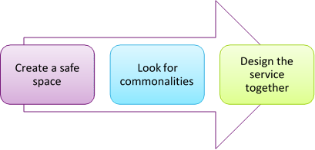

Figure 1 - Building shared purpose

The value in aim setting

Having the right aim is a fundamental part of starting your QI project.

The right aim will provide clarity, engage stakeholders, generate enthusiasm and enable measurement.

The aim should be a ‘stretch aim’, i.e.: an aspiration, not a target you reached within a week.

The aim should be SMART:
S | pecific | Who, what, where, when
M | easureable | Numeric goals, by how much?
A | ttainable | Within your influence
R | elevant | To stakeholders and organisation
T | imely | By when, give a precise date

Examples of aims
WEAK AIM | Why is it a weak aim? | STRONGER AIM
Reduce the no. of 4-hour breeches in ED. | S: Which ED?  M: Reduce by how much? T: By when? | Reduce the no. of 4 hour breeches by 50% in BTUH ED by 31 Dec 2017.
All new referrals to respiratory clinic must have an appointment within two weeks of referral. | S: Is it all respiratory clinics? Do patients need to have been seen or to have received their appointment letter within two weeks?  R: Relevant? ie: do all new referrals need to be seen within two weeks? T: By when? | All new referrals to the COPD clinic at BTUH need to have received their appointment letter within two weeks of referral by 31 December 2017.
95% of surgical admissions should have their medication prescribed in a timely manner by December 2014. | S: Which surgical admissions? What  is meant by ‘timely’?  T: Give an actual date! | 95% of emergency surgical admissions to SRU at BTUH should have their regular meds prescribed within 24 hours of admission by 31 December 2017.

Driver diagrams

A driver diagram sets out the plan for your QI project in a visual and effective diagram.

The diagram includes your SMART aim and the primary and secondary drivers which are needed to reach that aim:

Primary drivers: essential factors that need to be addressed to achieve the aim

Secondary drivers: factors that lead to your primary drivers – a secondary driver should lead directly to a primary driver, which should be essential to achieving your aim

Each primary driver is essential to your project, i.e.: without it, your project will not succeed.

Driver diagrams help identify the measures for your QI project as well as your “to do” list.

To start your driver diagram, have a session with your team where you:

Brainstorm all the factors needed to meet your aim using post-it notes

Group the factors as primary and secondary drivers

Driver Diagram Examples

Driver Diagram Examples
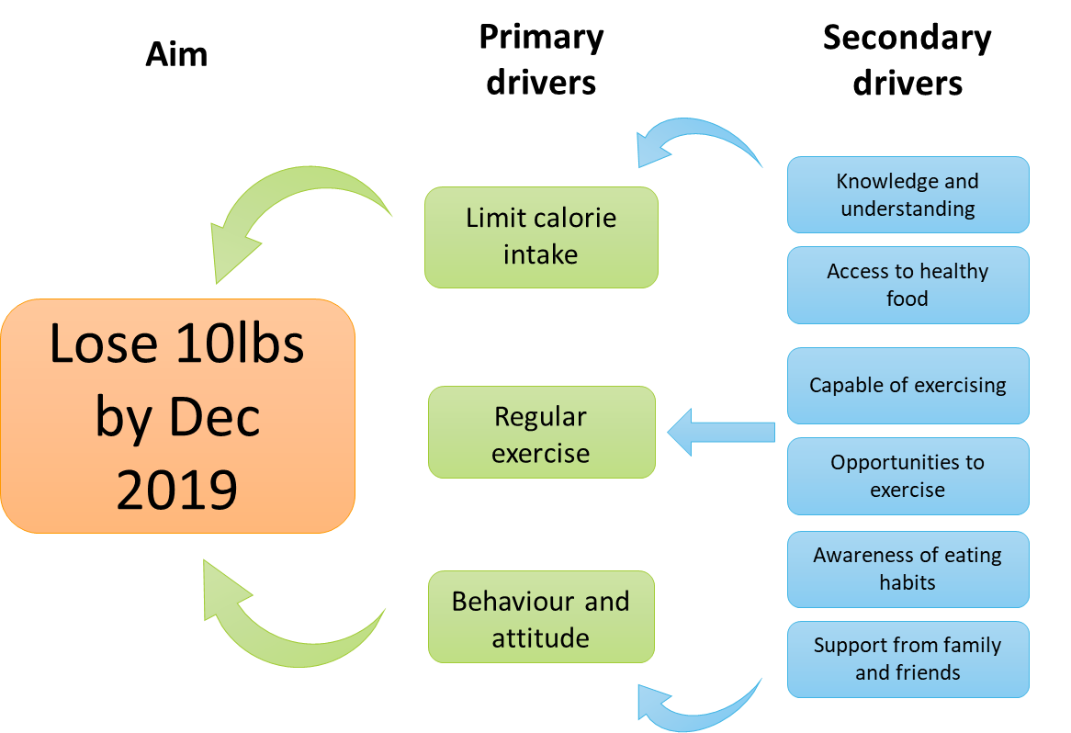

Figure 1 - Driver diagram example 1

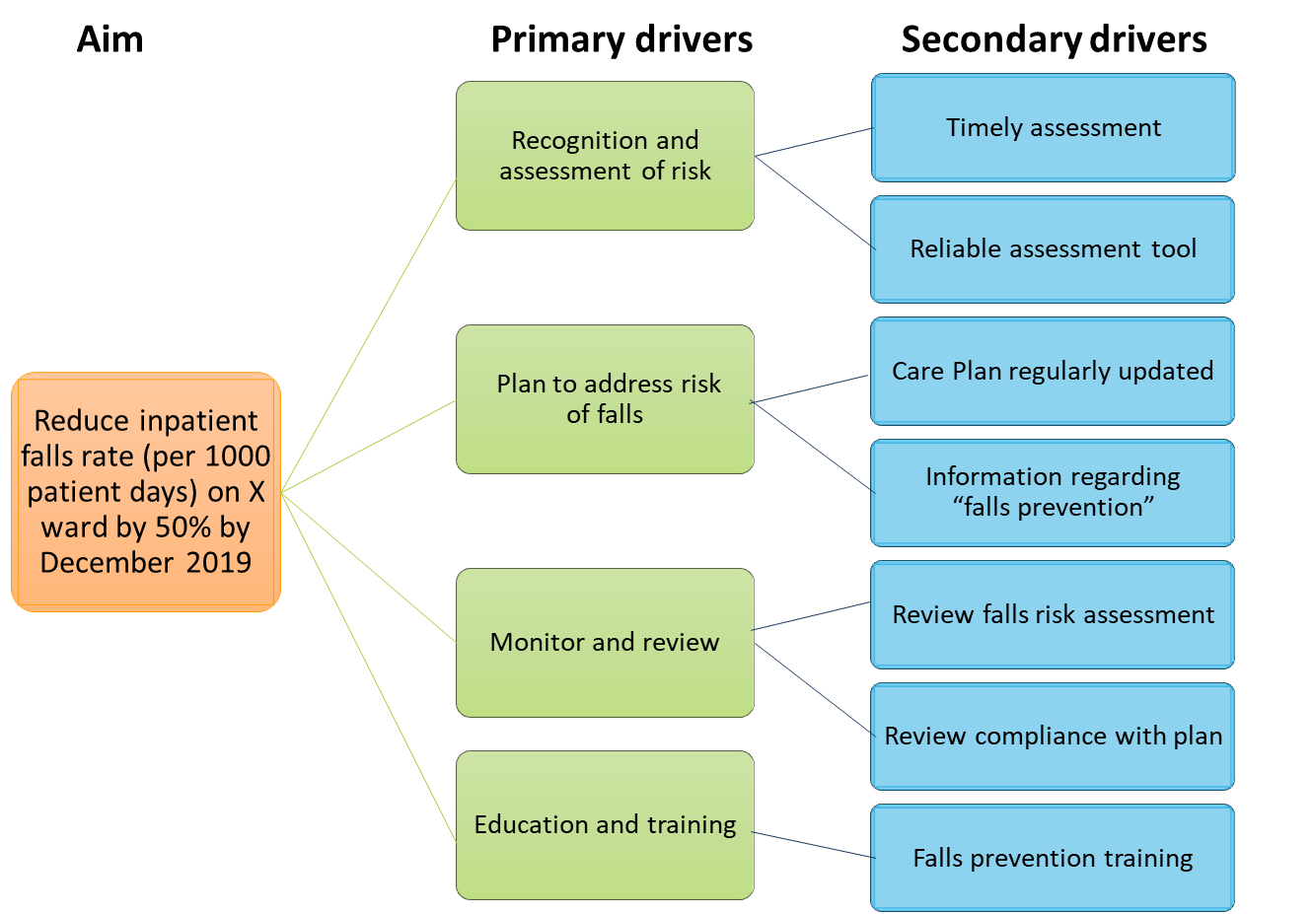

Figure 2 - Driver diagram example 2

Process mapping

Another way to understanding the current process is by mapping current activity through a process map.

The mapping of processes is used to create a visual representation of the relevant steps in a patient’s journey. Using these tools enables everyone involved in the different steps of the journey to see the overall picture of patient care and understand how complicated the journey can be for patients.

A process map sets out exactly what occurs in the system at that moment. It maps out the current pathway and can be used to identify problem areas, stakeholders and ideas for change.

Agree start and end points

Get mapping the steps in between.

How to use it

Mapping processes is a very empowering tool. It needs to be undertaken by the staff who work the processes - the people who know how things work. The process prompts good ideas and exposes frustrating problems. This helps teams to know where to start to make improvements that will have the biggest impact for patients, carers and staff.

There are different approaches to mapping patient journeys. Which one you select will depend upon:

What you need to know

Resources and timescales

Engagement and interest of staff.

Each approach gives you a slightly different perspective and you can use more than one approach to help confirm findings. The key is to reflect on how things are currently and then decide what the ideal journey should be like. All approaches will reveal:

Unnecessary steps, handovers and delays

Waste, such as duplication of effort

Things that don’t add value in the patient journey

Bottlenecks and constraints

Unhelpful variation in clinical and non-clinical practice

The potential for creating safer care

An understanding of the patient experience

Where to undertake further analysis e.g. understand demand and capacity and the flow through parts of the journey.

Example

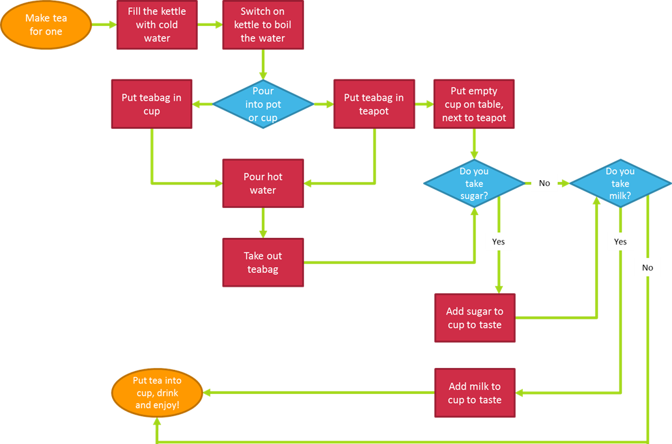

Figure 4 - Process map example: making a cup of tea

How will we know a change is an improvement?

We measure!

Rigorous, real time measurement is a key part of QI and should drive your project.

We need measurement to understand:

Current performance

If a change is an improvement

Variation

How to tell an improvement story

Progress and sustainability.

How do you measure for improvement?

Decide aim

Choose measures

Define measures

Collect data

Analyse data

Review and report

Repeat steps 4-6.
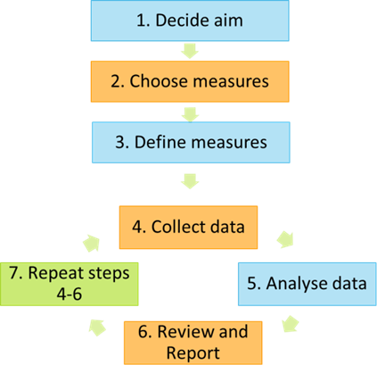

Figure 5 - Seven steps for measurement

There are four types of measures needed:

Outcome measure: this is your aim and should relate directly to the patient/population

Process measures: measuring the integral aspects of your system e.g. percentage pathways completed

Balancing measures: the knock-on effects of your project

Financial measure should not drive your project but need to be understood.

Example
Aim: Reduce pressure sores by 50% in six months.

Outcome measure:
- Percentage of patients being discharged with pressure sores
- Number of patients being treated with pressure sores.
Process measure:
- Percentage pressure ulcer care bundle filled in
- Number of staff remembering to get patients out of bed 3x/day
- Number of staff remembering to give inpatients pressure sores information.
Balancing measure: are more patients falling as they are being mobilised more so to decrease pressure ulcers? Measure the number of patients falling.
- Percentage of staff handing in daily checklists
- Percentage of staff who are happy with the changes on a scale of 1 to 5
Financial measures: costing attributed to reduction of pressure ulcers (can be part of outcome measure).

Baseline data

It is crucial you source baseline data when working out your measures to:

Helps you evaluate the current process

Acts as reference point

Helps you tell an improvement story.

When sourcing current or past data, it is important to check the following:

Is the data available and ready for use?

Was it collected recently?

Has the situation changed significantly since it was collected?

Do you know how and when the data was collected?

Is there sufficient data to make your conclusions valid?

Displaying data

The best way to display your data is to do so over time. Use a run chart to do so. Example of QI run chart
AIM: 95% of discharge summaries are sent on day of discharge in X Hospital.
Percentage
Week
10
9
8
7
6
5
4
3
2
1
100
80
60
40
20
0
Percentage of discharge summaries sent to the GP on same day as discharge

Target 95%

Variation

In QI, there are two main types of variation:

Common cause variation:

Regular

Due to the design of the process

Stable and predictable.

Special cause variation:

Irregular

Due to irregular or unnatural causes

Unstable and unpredictable.

Think about your daily commute to work. Let’s say it takes you between 40 and 60 minutes in total, depending on minor delays, the time you leave the house etc. This is common cause variation. This is random variation that is present in every process. But even with this variation the process is stable and predictable.

However, if something were to happen that was completely unexpected, like a tube strike or bad weather, which makes the process unstable and unpredictable, we have special cause variation.

Another example could be the impact of a flu outbreak on infection rates in a hospital.

Spotting variation

You can use your run chart to identify special cause variation and to show if you have made an improvement. There are three rules that show a change:

Shift:

≥ six consecutive data points above or below the median

Values that fall directly on the median are not included in this count and neither break nor add to a shift.

Trend:

≥ five consecutive data points above or below the median

Where the value of two or more consecutive points is the same, only include on in the count

In QI, there is either a trend or not. Charts are not described as “trending”.

Astronomical data point/outlier:

One data point is clearly different from all others

It could be some special cause variation, but often, it is an anomaly in the data.

Key rules of measurement for improvement
- Measure at daily or weekly intervals
- Aim for measurement to be in real time
- Ensure measurement is easy to understand
- Ensure measurement is part of your working routine and therefore easy to collect
- Annotate your charts with the tests of change you have tried, so you can learn from what you have tried and understand what has made a difference
- Sample size: needs to be ‘good enough’, not perfect. This is not research! You only need a
- sample size large enough to identify if you have a problem in your system
- Display your measurement: use run charts (time series charts).

What changes can we make that will result in improvement?
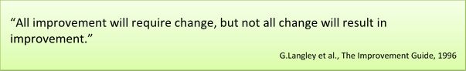

To improve a system, changes need to be tested to see if they make an improvement. Testing involves rigorous real time measurement.

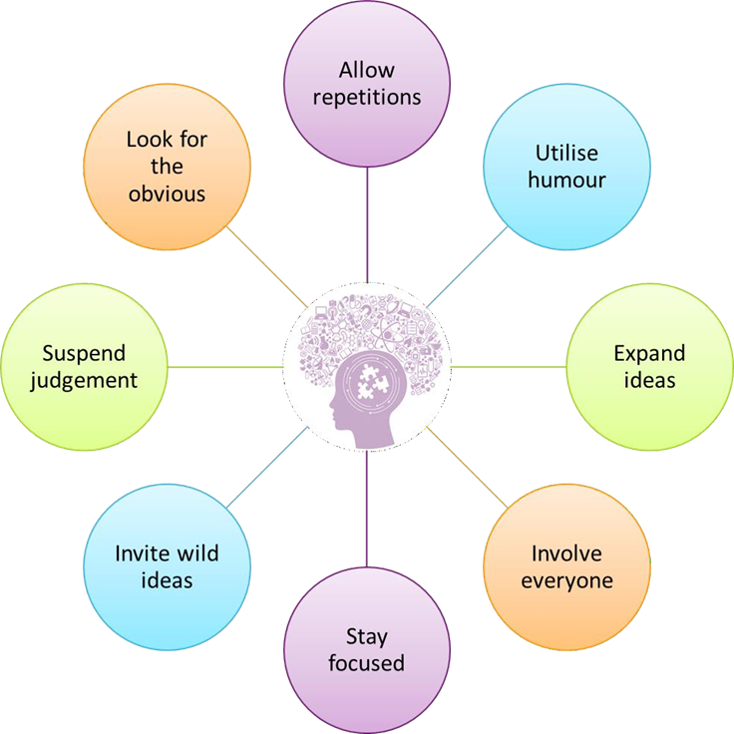
Brainstorming

Figure 6 - Brainstorming

Creative thinking

You can spark creative thinking in many ways. This could mean simply taking the time to do this sort of thinking. It means identifying the boundaries that limit the changes you can make and then brainstorming creative ways to overcome those boundaries. Expose yourself to a different point of view e.g. look at the situation from the perspective of a patient. This will help you to come up with different solutions for the problem.

To get your creative juices flowing, it is always handy to brainstorm ideas.

Creative team brainstorming improves your critical thinking and problem-solving skills as an individual and a team, encouraging collaboration. Team members often feel empowered and more open to bouncing ideas off one another and seek advice on individual projects, and creative

brainstorming works to include different perspectives and improves the team’s ability to think

outside the box.

Remember all ideas are acceptable; listen to everything your team members’ say without judgement. Think outside the box; the wilder the idea, the better. Quantity counts at this stage, not quality. There is no point in brainstorming a couple of ideas! Lastly, every person and every idea have equal worth – you have this team for a reason… They all have something to offer!

Behavioural Insights

In addition to using creative thinking, it can be helpful to spend some time looking at the behaviour changes you want to see because of your improvement project and how you might be able to influence them.

You may have heard of behavioural science. For those who haven’t it’s the intersection of psychology, neuroscience and economics. It’s sometimes referred to as ‘behavioural economics’, ‘behavioural insights’ or ‘nudge theory’. These all mean basically the same thing. It recognises that how decisions are presented affects our choices, that our decision-making is influenced by what others are doing, and that despite our best intentions we don’t always follow through with what we intend to do.

This is a relatively new and exciting area of applied science – certainly in the potential to apply it to improve health services. Though academics have been studying the quirks of human behaviour and human decision-making for 30 years. Applying behavioural sciences is about building policies, products and communications based on how people really do think and behave in real life - rather than on how we think they should think and behave. Very simply it’s the study of what we do, why we do it and how to influence it.

We often act in ways that seem surprising and irrational. This is something we can all relate to from our own personal lives as well as professional lives. We may not eat as healthily as we know we should, or save as much for our retirement as we know we should. Knowledge isn’t the barrier.

This implies that human decision-making is a lot more complex than we might have thought. This is true. A key insight from behavioural science is that human behaviour is more complex, less rational, and a lot more context specific than classic economics might have suggested.

What’s exciting is we’re starting to understand why and getting better at predicting when. Because while our brains have hardly changed in thousands of years, our understanding of how it works has increased greatly in the last 30 years or so.

Let’s try to understand a bit more about why people make systematic mistakes in how they make decisions. We’ll start by thinking about food. How many decisions a day do you think you make about food? Studies have shown that the average guess is about 14 but the actual number is 220.

More than 15 times what you think. Why? Mainly because it’s not just decisions you make to eat food but also ones you make not to, e.g. walk to work in the morning or when there are biscuits on a meeting room table.

The commonly accepted way of understanding and representing how we think is that we have two systems of thinking:

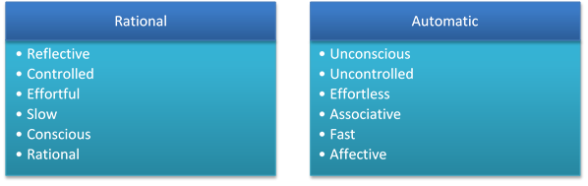

We use our automatic brain much more than we think we do and this tends to be where we make most of our day-to-day decisions. Think back to the food decisions example – there are so many decisions we are making unconsciously that we are unaware of. Using our slow/rational brain uses mental and physical energy, so our brains avoid using it where they can. The preference is for the easy thinking.

The challenge is there is so much in behavioural science and developing so quickly. Where do you start? The model we’ll show you was developed a couple of years ago by the ‘Behavioural Insights Team’ which is now a consultancy firm but began life in the Cabinet Office. It was nicknamed the

‘Nudge Unit’ as ‘nudges’ are the colloquial term for how behavioural insights can be applied in simple and light-touch ways.

The EAST framework they developed shows that, if you want to encourage a behaviour, make it Easy, Attractive, Social and Timely. These four simple principles for applying behavioural insights are based on the Behavioural Insights Team’s work and the wider academic literature. There is a large body of evidence on what influences behaviour. This framework does not attempt to reflect all its complexity and nuances, but it is a useful guide for policymakers and healthcare practitioners. It is a simple and memorable framework to think about effective behavioural approaches. A summary of the framework is on the next page and you can download it in full for free on their website:
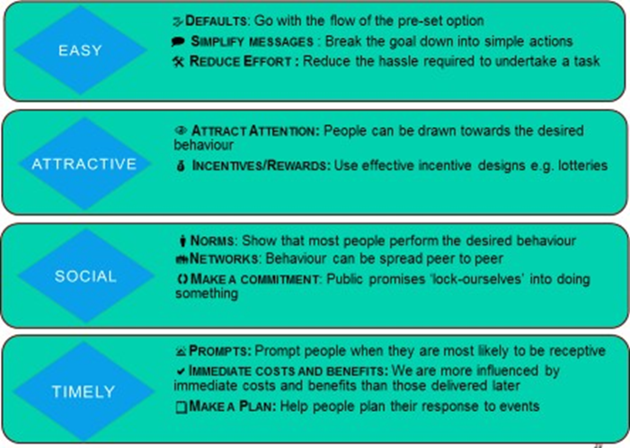

When it comes to applying the framework to your project, you can do this in four steps:

- Try to be as clear as possible about the specific behaviour you want to change. Be clear about who does what, where and when.
- What is the key metric? Can you use routinely collected data?
- How large an improvement is needed to justify doing the project?

- You need to understand the system from the user's and the provider's perspective - all too often
- decisions are made without understanding how the service is used or administered.
- Visit the situation and the people involved and, if possible, co-design the intervention with them

- Use the framework to develop ideas that you can test

- Use small tests of change to see if you need to refine your intervention

http://www.behaviouralinsights.co.uk/publications/east-four-simple-ways-to-apply- behavioural-insights/

Another way to think creatively is by using Edward De Bono’s Six Thinking Hats.

Six Thinking Hats

The Six Thinking Hats are flexible and adaptable to any situation, providing a systematic approach to collaboration, problem solving, strategic planning, and subject or idea evaluation, and much more. The techniques provide a disciplined process for individuals to focus on and assist them in getting to the point. It allows entire teams to look at all sides of an issue thoroughly and without confrontation, which is one of the approaches most important attribute, all in a fraction of the time which other traditional methods may take.

How to use:

In groups choose an idea and discuss using the six thinking hats.

To use the hats, someone in the group will be the leader of the session who will be wearing the blue hat. The person wearing the blue hat will coordinate the flow of conversation and ensuring each hat is using the same hat throughout the discussion. Each hat should get 3 to minutes which will result in a well-balanced view.

To maximise results, your chosen team members, which we worked out earlier today, will all wear a different coloured “hat” and will act based on the hat’s approach, whether it is feelings, processes, benefits, cautions etc. You should not wear the hat that you believe suits you and your thinking style but wear a different style and see how creatively you can think if you channel your thoughts that way.

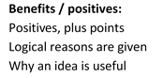
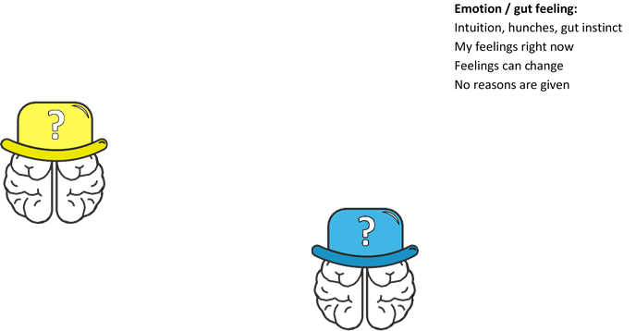
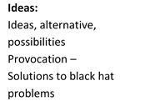
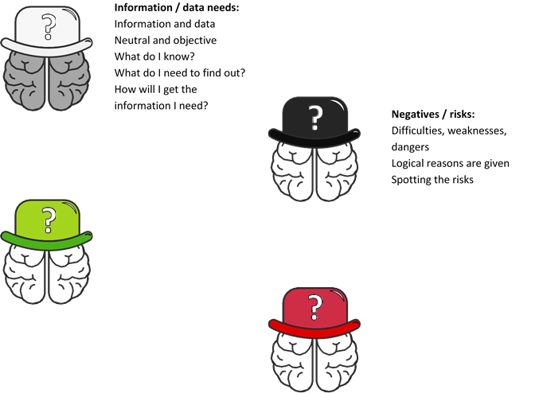

Figure 7 - Edward de Bono's six thinking hats

Change ideas

Change ideas are something specific enough to test and implement in any specific situation. They are an actual change to the current process.

Properties of a useful change idea:

Specific: can you describe what will happen when the data is used? Can you describe who, what, when, where, why, and how the idea will be put into practice?

Actionable/Feasible: Can you envision using the idea with current technology, resources and authority?

The innovation adoption curve
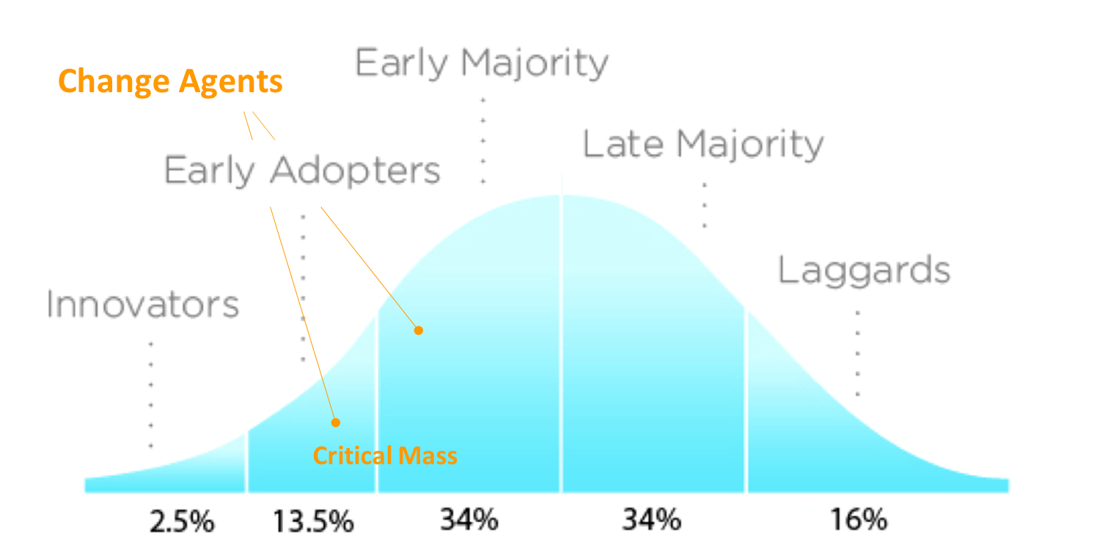

Figure 8 - Innovation adoption curve

Above we have the innovation adoption curve, which points out exactly who we need to target.

Ask yourself: which group would you target with your quality improvement project? Those who are first in line, or those who oppose change?

We don’t target the innovators, as if they are not already on your team, they want to be.

We don’t target the late majority and laggards, as they like things the way they are, and will eventually have to change.

We target the early adopters and early majority as they are the ones who are open to change. They may need some convincing and/or a push in the right direction, but they will change and they will help you!

Part 2

Testing change through PDSA cycles

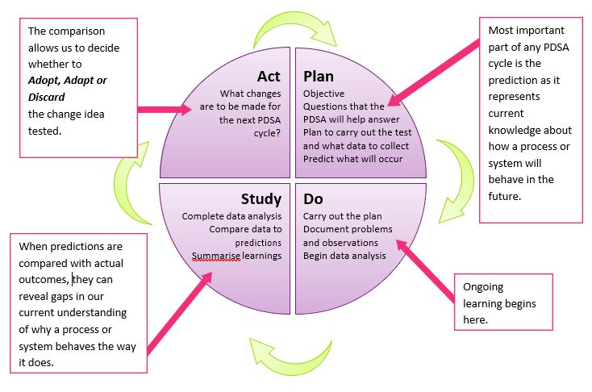
Plan, Do, Study, Act (PDSA) cycles

Figure 9 - Plan-Do-Study-Act Cycle

PDSA basics
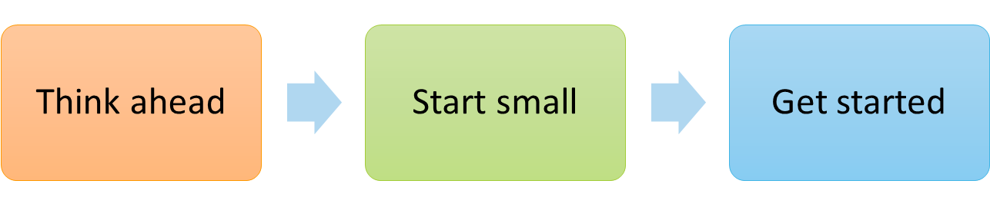

Figure 10 - PDSA basics

For each test of change, run the PDSA cycle as follows:
- Plan:
- What test of change do you want to try?
- Where are, you going to try it and on who?
- What do you expect to happen?
- How will you measure it?

- Do:
- Carry out the test and measure.

- Study:
- Analyse your results
- What happened when you ran the test?
- Did it meet your expectations?

- Act:
- Adopt, adapt or discard the change
- Perhaps test it on more patients?
- Try a new test of change.

Features of PDSAs
- Keep tests small so failures cause minimal damage
- Measure, so you understand the impact of any change
- Annotate your run charts with your tests of change
- Don’t change the system until you understand the impact of changes
- Retest the change in each new environment e.g., don’t assume a pathway which has been tested in one clinic will work in the next clinic
- Give team members ownership of different tests
- Celebrate failures, this is useful information too.

Example
Aim: 95% of discharge summaries are sent on day of discharge in Hospital X.
CYCLE | PLAN | DO | STUDY | ACT
PDSA 1 | Hold a teaching session with the  team’s junior doctors  Plan how to measure to see if this increases the number of discharges sent the same day  Write a survey for the doctors, what did they think of the teaching session? | Hold the teaching session  Measure weekly the no. discharge summaries sent to the GP on the same day as discharge  Conduct the survey amongst the doctors | What did the measurements show?  What did the survey show? | Adopt, reject or redesign the teaching session  Trial it again Try another
PDSA 2 | Could ward clerks send the summaries? Ask ward clerk, doctors, nurses?  Plan a trial on one day with one ward clerk  Plan how to measure the change:  - % summaries sent on the same day?  - What did the ward clerk think? | Trial on one day with one ward clerk, with one team on one ward  Measure:  - % summaries sent on the same day?  - Ask the ward clerk/doctors how it went? | Analyse the measurements and review the ward  clerk’s/doctors’  views | Adopt, reject, adapt the system  Consider trialling it one every weekday for that team on that ward
PDSA 3 | Could consultants get a weekly report of their teams’ results to feedback to the team?  If agreed, plan a trial and measure:  - % summaries sent the same day  - Opinion of those involved? | Trial it on one week with one team on one ward  Measure:  - % summaries sent on same day?  - Team’s opinion | Analyse the results | Adopt, adapt, reject





You can then develop your run chart by annotating the changes you have tested:
Week
10
9
8
7
6
5
4
3
2
1
60

40

20

0
Teaching session to all junior
doctors. PDSA 1
100

80
Consultants given weekly report of results
for their teams. PDSA 3
New pathway written, ward clerks to send
finished summaries. PDSA 2
Target 95%
Percentage of discharge summaries sent to the GP on same day as discharge

PDSA Example
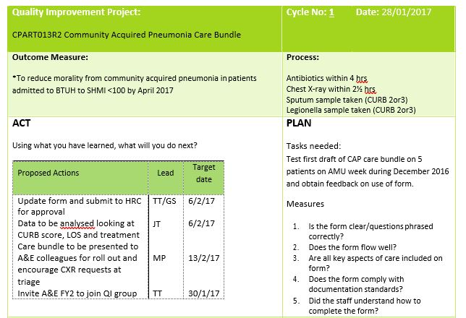

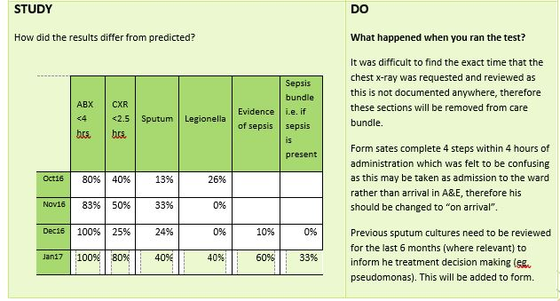

Q & A Aim:
Can quality improvement save money?
It is widely believed that quality improvement should be a key part of an organisation’s mission as it can improve patient experience and outcomes, and can bring financial and productivity benefits for the organisation. A 2009 review found that quality improvement can make an important, if limited, contribution to the cost-efficiency of healthcare.1 For example:
- Continuing with poor or sub-optimal care results in unnecessary costs
- Longer stays for patients’ due to healthcare-acquired problems, such as infections or pressure ulcers, add to hospital costs
- Improving care and hygiene standards will reduce costs per case, and can boost productivity such as throughput of patients per bed
- Issues that can be addressed to produce cost savings in healthcare include:
- Delays, such as patients waiting for tests
- Reworking (performing the same task more than once)
- Overproduction, such as unnecessary tests
- Unnecessary movement of materials or people
- ‘defects’, such as medication errors
- Decreased morale, through the problems staff face on a daily basis not being addressed.
Do we need a team of experts to lead quality improvement in our organisation?
Quality improvement approaches are underpinned by a philosophy and a set of competencies. For this reason, research indicates that quality improvement initiatives are more successful if frontline staff are supported by facilitators who have capability in quality improvement methods, approaches, tools and techniques. However, building the organisation’s capability for quality improvement is also important, and this should be part of the organisation’s overall quality improvement strategy.2
How can quality improvement approaches help productivity?
A key challenge for NHS organisations over the coming years will be to ensure that they achieve the best possible value for money – with quality of care embedded within that concept. For providers, reducing variation, streamlining processes, cutting out waste and reducing errors can contribute to more a productive system and workforce. From a commissioner’s perspective, evidence shows that there can be variation in the value for money achieved by different commissioning bodies. This suggests that there is scope either for improving quality outcomes without increasing spending, or for retaining current outcomes while spending less. Incentives within contracting also contribute to the drive to improve quality. For example, the CQUIN payment framework is the mechanism through which commissioners are able to contract for quality improvement, and the way providers are able to secure resources additional to those specified in the contract for services.

- Øvretveit J. Does improving quality save money? A review of the evidence of which improvements to quality reduce costs to health service providers. London: Health Foundation, 2009.
- See: www.health.org.uk/publications/quality-improvementtraining-for-healthcare-professionals/

What is the link between quality improvement and patient safety?

In recent years, it has been widely recognised that unnecessary harm happens in the process of providing healthcare. Quality improvement approaches are increasingly being used to address these system failings. The reliability of the application of evidence has been used as a key approach in several national initiatives3 to encourage healthcare organisations to measure and aim to reduce harm.

Measurement:

Why is there such a focus on variation in quality improvement?

There are two broad types of variation in healthcare: variation in the organisation of services or processes and variation in clinical practice. Quality improvement approaches are focused on improving processes, systems and, sometimes, clinical practice. Variation in the systems and processes adopted in healthcare leads to inefficiency, waste and increased waiting times. In clinical processes, variation from an established evidence-based best practice can result in error and harm, as well as poor outcomes for the patient. Addressing this can be described as increasing the reliability of care – a key component of which is standardisation. However, a certain amount of variation is considered normal, so it is important to understand how variation works. Many quality improvement approaches assess whether a system, process or clinical practice is within control limits. They then use this as a key measurement tool, to help understand the level of variation in the system and to measure it over time.

Changes:

What are the barriers to successful quality improvement?

In a study of 14 quality improvement programme evaluations4, 10 key challenges were consistently identified from the programmes. These were:

- Convincing people that there is a problem
- Convincing people that the solution chosen is the right one
- Getting data collection and monitoring systems right
- Excess ambitions and ‘projectness’
- The organisational context, culture and capacities
- Tribalism and lack of staff engagement
- Leadership
- Balancing carrots and sticks – harnessing commitment through incentives and potential sanctions
- Securing sustainability
- Considering the side effects of change. However, the evaluations also showed that if you take thetime to get an intervention’s theory of change, measurement and stakeholder engagement right, this will deliver the enthusiasm, momentum and profound results that characterise improvement at its best.

Adapted from: The Health Foundation: Quality improvement made simple, what everyone should know about health care quality improvement

- For example, see: www.patientsafetyfirst.nhs.uk
and www.scottishpatientsafetyprogramme.scot.nhs.uk
- Dixon-Woods M, McNicol S, Martin G. Overcoming challenges to improvement. London: Health Foundation, 2012. www.health.org.uk/overcoming-challenges

Life platform
Remember to sign up to the Life QI platform on www.life.seedata.co.uk. Life is a powerful online platform to support and project manage small and large improvement projects alike within your team and beyond. It also acts as a point of sharing and learning as well as inspiration for quality improvement


Further support
The Quality and Capability team at UCLPartners will always be able to offer additional support. We are offering a range of support opportunities for individuals and organisations.

Please get in touch to discuss how we can support you, your team and your organisation to succeed with quality improvement projects – be it bespoke training or project clinics for quality improvement and measurement:

QI@UCLPartners.com

Life@UCLPartners.com

Acknowledgements
Gabriella Massa
Senior Improvement Coach, UCLPartners

Emma Mordaunt
Improvement Project Manager, UCLPartners

Alexandra Hellyer
Improvement Advisor, UCLPartners

Appendix A: Stakeholder Analysis
Purpose
To improve service delivery processes, you need to actively engage a wide variety of people such as clinicians, administrative staff, patients and user groups. A stakeholder analysis enables you to identify everyone who needs to be involved in a change project. The more important the stakeholder is to the success of the project, the more time and resources you need to devote to maintaining their involvement and commitment.
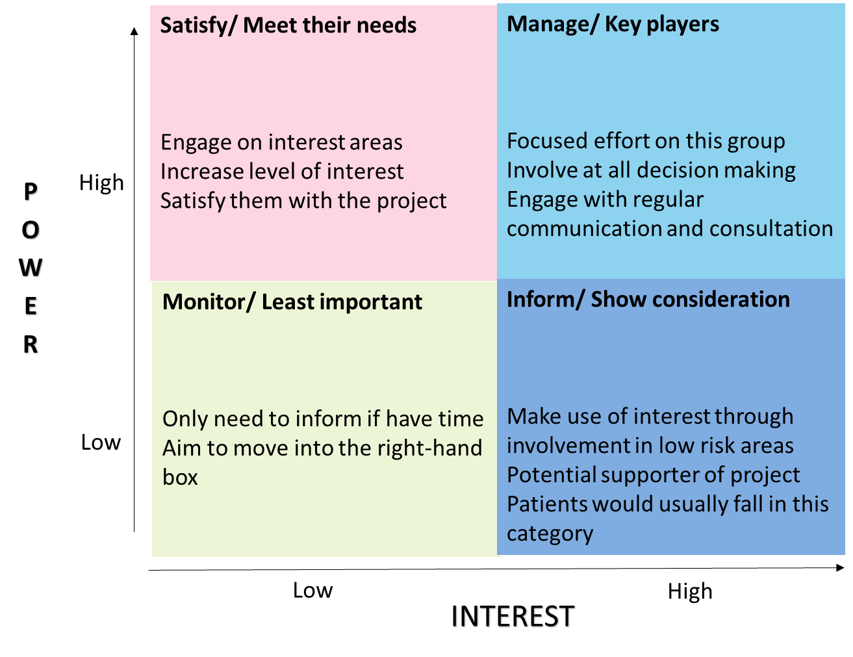

Name | Contact Details | How much will the project impact them (Low, Medium, High) | How much influence will they have over the project (Low, Medium,  High) | How will they contribute to the project? | How could they block the project? | How will you engage

Glossary
Knowledge Base, Method, Tool, or Skill | Description of Knowledge Base, Skill, Method, Tool
Driver Diagram | A diagram that organizes the theory of improvement for a project and thus provides a learning structure for the project. The structure connects Aim, measures and creates a theory-based organization of the changes
PDSA Cycle | A structure for learning and improvement. One of the components of the Model for Improvement. The four steps in the cycle are: Plan, Do, Study, Act. It is also known as the Deming cycle, Shewhart cycle, and the PDCA cycle.
Use of Data | Use of data for learning, e.g. identifying information in the patterns of variation in data and using this to guide actions for improvement. Includes understanding the value of plotting data over time, the pitfalls of viewing before/after data and an understanding of common sources of bias. Also, understanding the differences between purpose of data used for improvement, accountability and  research
Developing Changes | Aiding others to develop more powerful changes than those previously tried. Includes diving deeply into an understanding of process and systems, using creative thinking techniques (e.g. change concepts, concept triangle, provocations) and making use of new or existing technology.
Testing Changes | Putting a change into effect on a temporary basis using the PDSA cycle. Trying change, typically on a small scale first, then using multiple PDSA cycles increasing size, scope, and conditions under which change is tested to improve confidence, staff readiness and reduce cost of failure prior to implementation. Principles of experimental design are incorporated into test designs
Conducting Meetings | Includes understanding how to structure team meetings so they are more effective and efficient. Includes knowledge related to clarifying roles and responsibilities of team members, team leader, facilitator, technical consultant and management sponsor, clarifying agenda items, timeframes, expected outcomes, decision making methods, meeting documentation and physical environment for  the meeting.
Group Dynamics | Improving team functioning through understanding of how individuals behave when in a group. Includes understanding of the need for clarity of purpose (charter), clarity of behavioural expectations (norms), typical stages of group development, use of discussion and of dialogue,  avoidance of “group think” and methods for evaluating, monitoring and improving group interaction  in meetings.
Creativity Methods | A collection of techniques for tapping into the unconscious mind for new ideas that lead to different ways of attacking a problem or accomplishing a task. Also, called lateral thinking methods. Methods include six thinking hats, provocations, random word, and concept triangle.
Run Chart | A graphical record of a measure plotted over time. May include median line and/or a goal line.
Statistical Process Control (SPC) Chart | A method used to distinguish between variation in a process due to common causes and variation due to special causes. It is constructed by obtaining measurements of some characteristic of a process, summarizing with an appropriate statistic, and grouping the data by time period, location, or other process descriptive variables. There are many different types of control charts, depending on  the statistic analysed on the chart.
Designing Tests of Change | Designing studies (before-and-after, simultaneous comparisons, planned grouping) to determine the effect of a specific change to a process. Use the principles for testing a change to understand the effect of the change.

Examples
Quality Improvement case studies

Quality improvement project to increase the knowledge and confidence of Anaesthetists at managing dental trauma.

Background
Dental injury is frequently encountered during anaesthesia and is the most common cause of medico-legal claims made against anaesthetists.
Dental trauma, and in particular avulsion, is even more likely when anaesthetising children as they often have immature root completion in addition to more elastic alveolar bone compared with adults. The prompt management of these cases is the most important factor in ensuring these teeth will have the best successful long-term prognosis. As a result, it is essential for all those involved with anaesthesia to have the knowledge to confidently deal with dental trauma, especially in a children’s hospital such as Great Ormond Street.
Aim
To assess and improve the level of knowledge anaesthetists had of dental trauma, enabling better patient outcomes should dental trauma arise.
Don’t forget an aim should be measurable and timely

Method
I produced a survey which was sent both electronically and in paper form to the
Anaesthetics Department at Great Ormond Street Children’s Hospital. This survey was kindly filled out by thirty-four members of the Anaesthetics Department ranging from Consultants to Anaesthetic ODPs. The following eleven questions were asked on the survey:
- What is your current level of training?
- Do you usually consent for dental trauma?
- Have you encountered dental trauma during intubation?
- If so, during what kind of procedure have you encountered dental trauma most frequently?
- Are you aware of local guidelines in management of dental trauma?
- Are you aware of national guidelines in management of dental trauma?
- The final five questions involved different clinical scenarios which tested their knowledge on a range of situations involving dental trauma.

Results
- Only 29% of anaesthetists always consent for dental trauma despite the fact that 65% had encountered it during their career.
- 59% of anaesthetists incorrectly believed there were local guidelines for managing dental trauma and only 35% were aware there are national guidelines.
- 59% of anaesthetists would not know how to manage an avulsed adult tooth from a fit and healthy ten-year-old boy
- 26% of anaesthetists would incorrectly reimplant an avulsed baby tooth.
- 24% of anaesthetists would incorrectly reimplant an avulsed adult tooth on a patient who suffered from infective endocarditis.
- 48% of anaesthetists did not know milk was the best storage media for an avulsed adult tooth if not reimplanted straight away.

PDSA Changes
- The creation of a presentation on ‘How to deal with Dental Trauma’ which has
- been electronically sent to all Anaesthetists in the Hospital
- The creation of local dental trauma guidelines based on the national guidelines for Anaesthetists.

Conclusion
The survey highlighted that the management of dental trauma was a weakness for many anaesthetists with a number of deficiencies relating to lack of dental knowledge and confidence. I believe that through the implanted changes of this quality improvement project many of these deficiencies will be addressed, and as a result patient care will be greatly improved.

Quality Improvement Project to Improve Paediatrics Sepsis
Context
The improvement work was undertaken as part of Reducing Sepsis Mortality at Basildon University Hospital NHS Foundation Trust. It is a clinical ward base programme involving Multi-disciplinary Teams
Problem
Paediatric Sepsis 6 was rolled out nationally in 2015. Prior to this time, we were not using any sepsis pathway and staff were unaware of sepsis bundle. The emergency department has the highest volume of attendances of un-well children but there is nothing in place to enable staff trigger sepsis alert on the system. There was no training on sepsis awareness and Sepsis cases were not identified on time.
Assessment of problem and analysis of its causes
Baseline data was collected and analysed, and the main problem was administering antibiotics within the 1st hour of booking in. A deep dive into the cause showed that target is not met due to the amount of time it takes to do Lumbar punction on suspected sepsis before Ceftriaxone infusion is given. Sepsis awareness was minimal.
Aim
100% compliance with Paediatric Sepsis pathway by 31st December 2016
Intervention
- Weekly team meeting
- Measurement for Improvement- Smart Aim, drivers, real time process measurement and cycles of PDSAs
- Lean- we eliminated unnecessary time spent: the antibiotic given was an infusion, we changed this to a drug that could be administered by bolus and just as effective.
- Project Management- We used our workbook to monitor our task completion.
- Theory of constraint- We removed the bottle neck of not being able to flag suspected sepsis by adding the command to the system and that took off going through 100+ notes to measure adequate identification and treatment of sepsis.
Strategy for change
- Project Team was formed, and they meet weekly to analyse data collected and test their changes.
- Consulted with pharmacist to change from Ceftriaxone infusion to Cefataxime as first line IVAB given a bolus rather than infusion.
- System modified to include sepsis triggering
- Sepsis awareness day in all paediatrics area
- Training to Dr’s & Nurses
- Sepsis trolley (Ordered May 2016)
- Posters in clinical area

- Sepsis included at Ward meetings, huddles and handover
- Review in real time all proformas completed to measure compliance with 6 components

Measurement for improvement
Outcome measure - number of Sepsis Mortality.
Process measures were derived from 4 CQUIN measures.
Balancing measure - number of antibiotics is reviewed and discontinued to avoid unnecessary Antibiotic administration.

Method: 7 tests of changes (PDSA) were done.
Effects of changes: Sepsis awareness created
- Children with suspected sepsis were identified in a timely manner.
- Real time measurement of all sepsis cases for learning and sharing.
- Enthusiasm among the project team members to carry on the improvement
- Staff Morale has increased

Lessons learnt
- Always have a pathway and proforma that people will follow
- Recurrent teaching and real time measurement are key to improvement

Message for others
“It had worked, just get committed”


Introduction to Quality Improvement by UCLPartners is licensed under a Creative Commons Attribution-NonCommercial-Share Alike 4.0 International License. You must give appropriate credit to UCLPartners, provide a link to the license, and indicate if changes were made. You may do so in any reasonable manner, but not in any way that suggests the licensor endorses you or your use. You may not use the materials for commercial purposes. Click here for more info.
E: QI@uclpartners.com W: www.uclpartners.com Mailing address: 3rd Floor 170 Tottenham Court Road
London, W1T 7HA @UCLPartners #UCLPQI

